These activities are really skills for life and should, therefore, begin as early as possible and involve everyone working with the child. There should be a commonality of approach and of language used with the child so that, for example, directional instruction remains the same. This avoids confusion for the child and the adults!
Toileting
- Bribery – in any form – rules OK! Keep a packet of Smarties or similar on hand or used taped songs or favourite toys, anything that constitutes a reward.
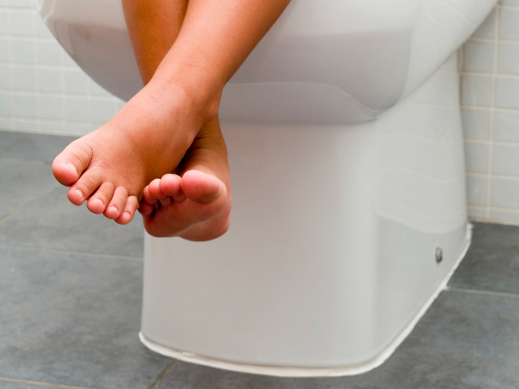
- Use the same routine every time on entering and leaving the toilet. Think about a simple route in and out and add any tactile points in the room that the child may understand bells on the door, elastic band on the handle)
- Be flexible about the use of the potty or toilet. A lot of visually impaired children fear sitting on a toilet. Do not leave them on their own, offer lots of talk and support such as holding hands. Singing aloud helps too!
- Some children need to ‘look’ at what they have done and where it is! Don’t be too squeamish about it, although it can be discouraged as the child develops the skill.
- Use the flush system as a reward. Most children love to hear it and do it for themselves.
- Be sure the child always does the whole process, including hand washing every time.
- Make a huge fuss at every success – accept accidents, and there will be many! But take the child to the bathroom to change wet clothes so that the act becomes associated with the appropriate places

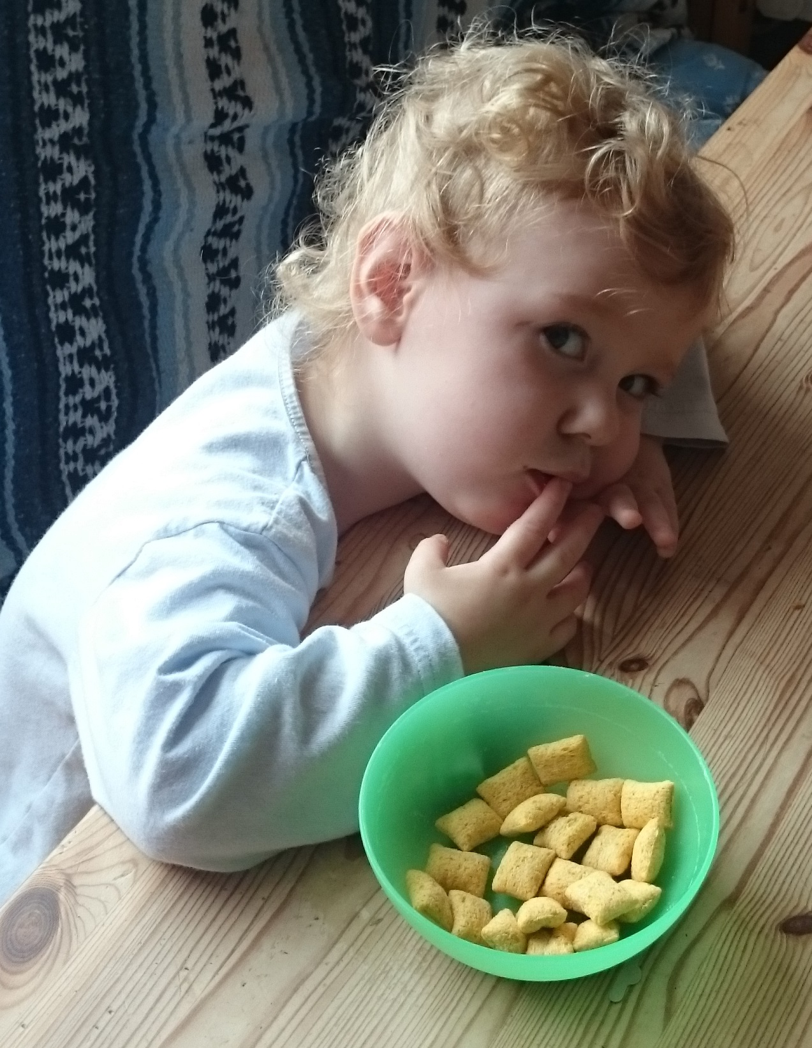
Eating
- Fingers were invented before forks, so concentrate on them first.
- Many visually impaired children develop preferences for hard edged foods like burgers and chips. They dislike foods with poor definition such as yoghurt with bits in. Give a commentary about what you are offering.
- A dycem mat ( or damp cloth) under a child’s plate keeps the plate still and in the same direction.
- Try to used rimmed plates with a good contrast to the table, such as blue on yellow.
- Use hand on hand technique when starting to use tools and begin with spoon and fork. Some cutlery has enlarged grips and may be useful.
- Be prepared for mess and clean the child up at the very end. State what you are doing. Don’t comment on refused foods, try again another time.
- Let the child feel your own jaw when chewing and listen to you eating crunchy foods. They will love it!
Dressing and undressing
- Encourage easy clothes like track suit bottoms. All fastenings are a problem and make everyone frustrated. Avoid getting heads stuck!
- Begin by letting the child do as much or little as he/she can, which may be pulling off a sock. Praise!
- Arrange clothing on a chair, where the child can return to dress again. Place items over the back in the order that they come off, put socks and shoes underneath the chair.
- The backs of clothing can be marked with a small button, or piece of Velcro on the label at the neck. Choose Velcro wherever you can – children love the sound of it. They love zips too!
- Coats with hoods can be placed on the back of the head to start putting the coat on. Add extra length to zips with a safety pin or paper clip to ease movement up and down.
- Have a variety of fastenings on good quality cloth to play with .
- Be patient and praised every time. Try to put the child occasionally in the position where time does not matter for dressing and undressing.

If you would like more help or advice please speak to your nursery teacher, visiting teacher or habilitation specialist.

Daily Living Skills

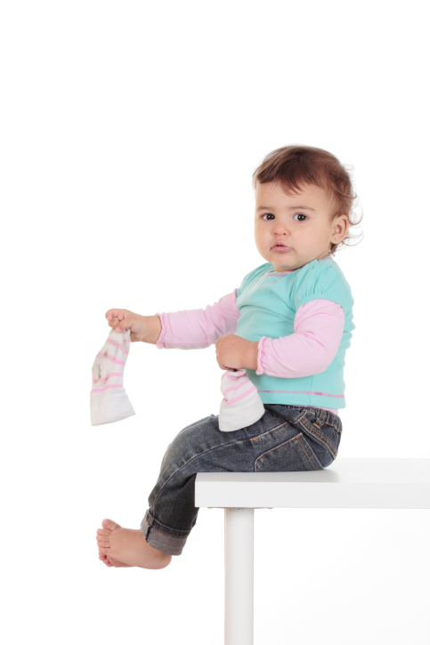
Activities for
Visually Impaired
pre-schoolers

